Facility Locator

Product Guide

## 

What is the Facility Locator? 2

User Access 3

Who can access these tools? 3

How can users access these tools? 3

Navigation 4

Landing page (search page) 4

Facility Detail page 4

Legacy directory link 5

Search Functionality 6

Location 6

VA facility type 6

VA health 7

Urgent care 7

Alert for Community urgent care providers (in VA network) 7

Community pharmacies (in VA network) 8

VA benefits 10

VA cemeteries 11

Vet Centers 11

“Search this area of the map” 11

Search Results 12

VA facility search results 13

Community provider search results 14

Facility Detail Pages 15

VA facility types 16

Community providers (in VA network) 18

Facility-Level Operating Status 19

Error states and steps for resolution 20

FAQ 20

Update Log 20

## 

## 

## 

## What is the Facility Locator?

Facility Locator is VA’s source for Veterans to find details about all VA- and VA-approved facilities across VHA, VBA, NCA, and Community Care. It serves many purposes, from finding basic facility address and phone information to preparing to visit a VA facility.

## User Access

### Who can access these tools?

Anyone can access VA.gov Facility Locator. It is part of the unauthenticated experience and can be accessed publicly.

### How can users access these tools?

Via <https://www.va.gov/find-locations> or “Find a VA Location” at [https://www.va.gov](https://www.va.gov/).

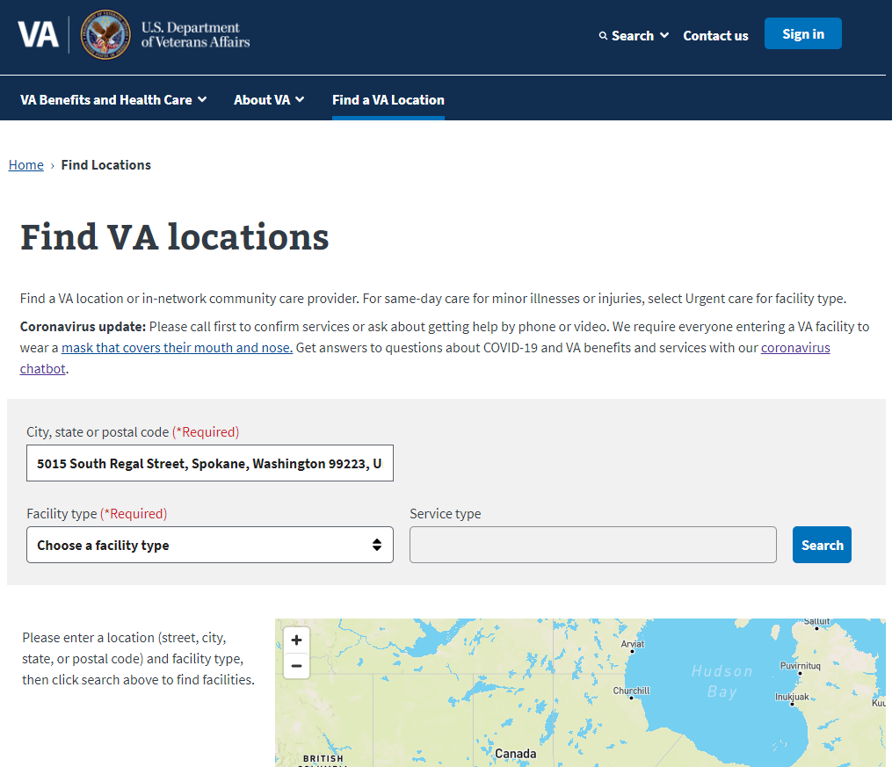

## 

## Navigation

Facility Locator has two primary pages:

### Landing page (search page)

Facility searches are performed on this page by inputting location, VA facility type, and Service type (if indicated). The user can also enable their location through the browser when prompted. When the Veteran lands on the search page, the fields are empty by default, unless he/she has navigated from another page which auto-populates the Facility type field.

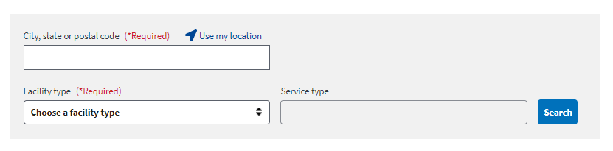

### 

### Facility Detail page

Additional information about the facility can be found by clicking on the name of the location in the search results box.

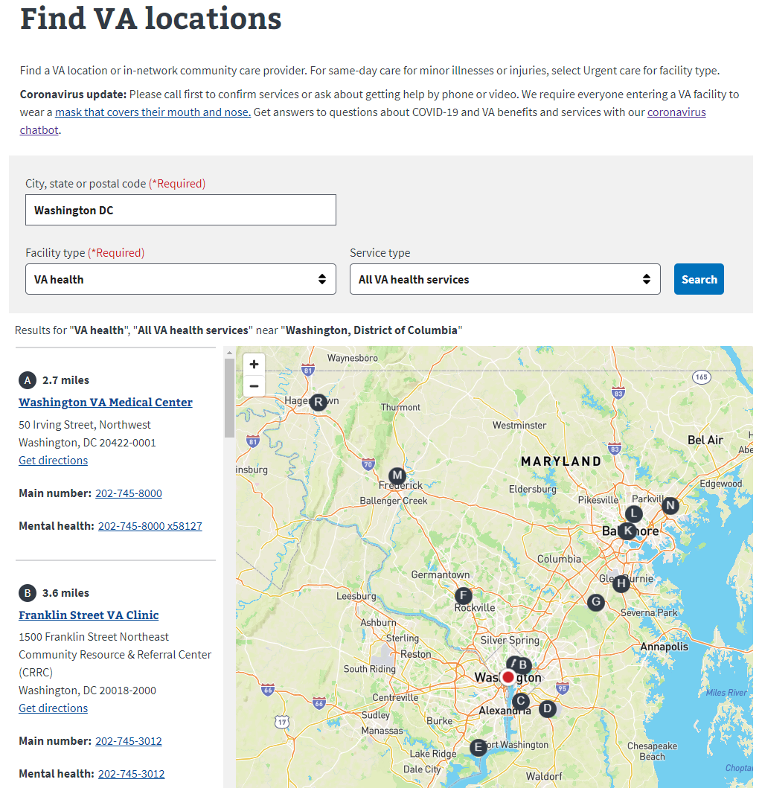

This type of page is not available for community urgent care providers or pharmacies.

### Legacy directory link

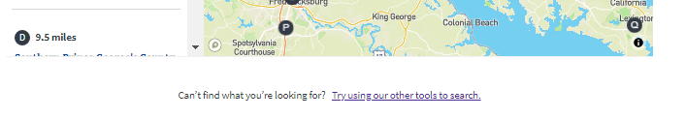

The link below the map connects users to the legacy directory. Once the modernized Facility Locator has reached parity with the legacy directory, this link will be sunset.

## Search Functionality

### Location

The location field is mandatory. Users may enter the city, state, and zip or enable location in their browser.

By default, unless the user enters a street address, the search will be performed based on the center point of the location parameters entered (the center of the city or zip code, for example).

### VA facility type

The user must then choose a VA facility type from the drop-down list of options. The field defaults to “Choose a facility type.”

#### VA health

If VA health is selected, it defaults to All VA health services, and the user should just click Search.

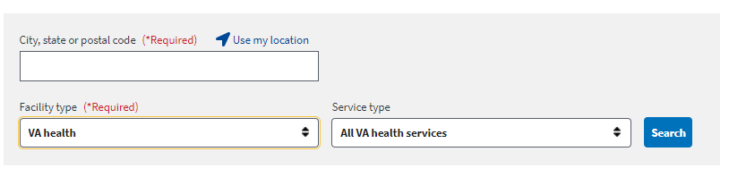

#### Urgent care

If Urgent care is selected, the user should choose

* VA urgent care to see results for VA owned and operated locations
* Community urgent care providers (in VA network) to view urgent care facilities and walk-in/retail locations
* All urgent care to view a list containing VA locations and community providers

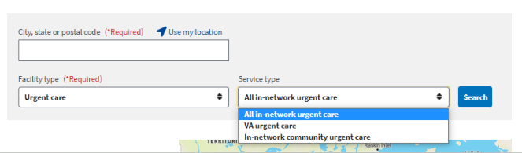

##### 

##### Alert for Community urgent care providers (in VA network)

Users searching All urgent care or urgent care plus Community urgent care providers in VA network will see an alert within any Community care result cards. Clicking the button directs the user to a page from the Office of Community Care. The page provides information regarding the urgent care benefit, including billing information for the Veteran and providers.

#### 

#### Community pharmacies (in VA network)

If Community pharmacies (in VA network) is selected, no Service type is needed, and the user should just click Search.

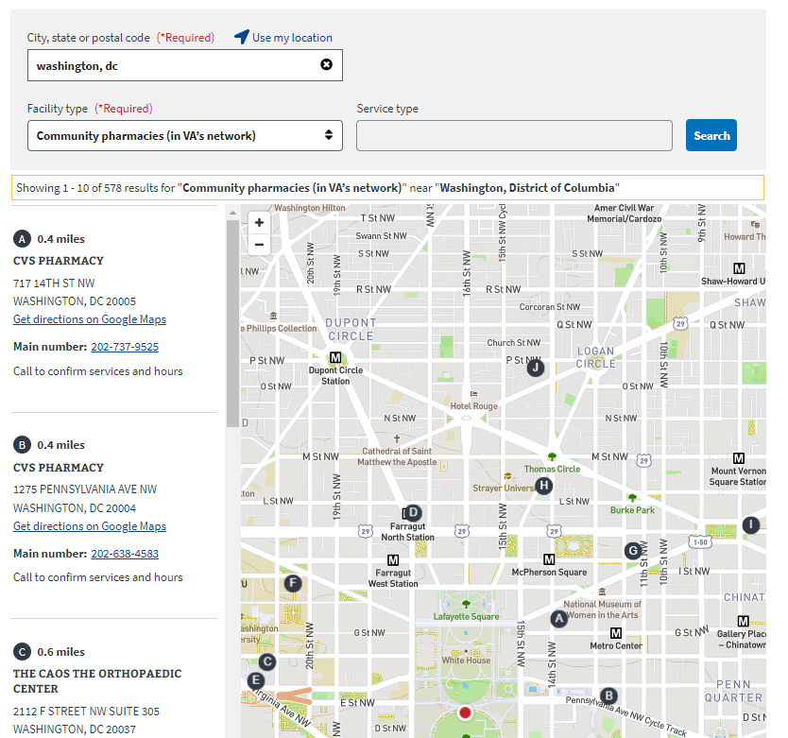

**Community providers (in VA network)**

If Community providers (in VA network) is selected, the user must populate the typeahead Service type field with a type of care (such as primary care or podiatry) and then select an option before clicking Search.

#### 

#### VA benefits

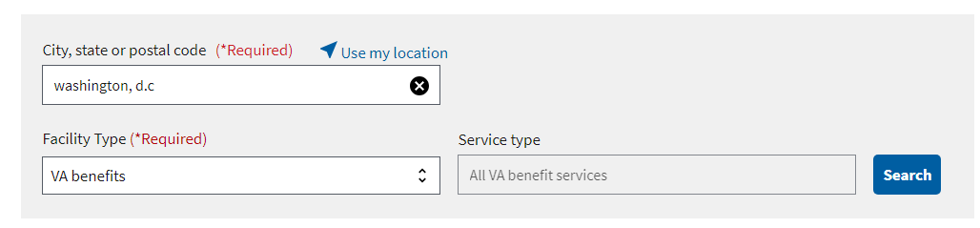If VA benefits is selected, no Service type is needed, and the user should just click Search.

#### VA cemeteries

If VA cemeteries is selected, no Service type is needed, and the user should just click Search.

#### 

#### Vet Centers

If Vet Centers is selected, no Service type is needed, and the user should just click Search.

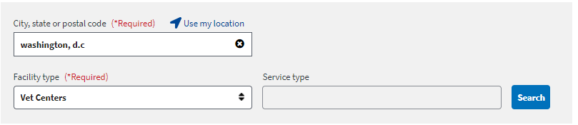

#### “Search this area of the map”

As of December 2020, once search results are returned, if the Veteran zooms or pans the map, a new “Search this area of the map” button displays at the top of the map. Clicking the button will trigger a new search.

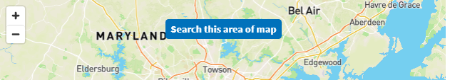

## 

## Search Results

Regardless of VA facility or service type chosen, the results will be presented on one or more cards in a list next to the map. The results are presented in ascending order, based on distance.

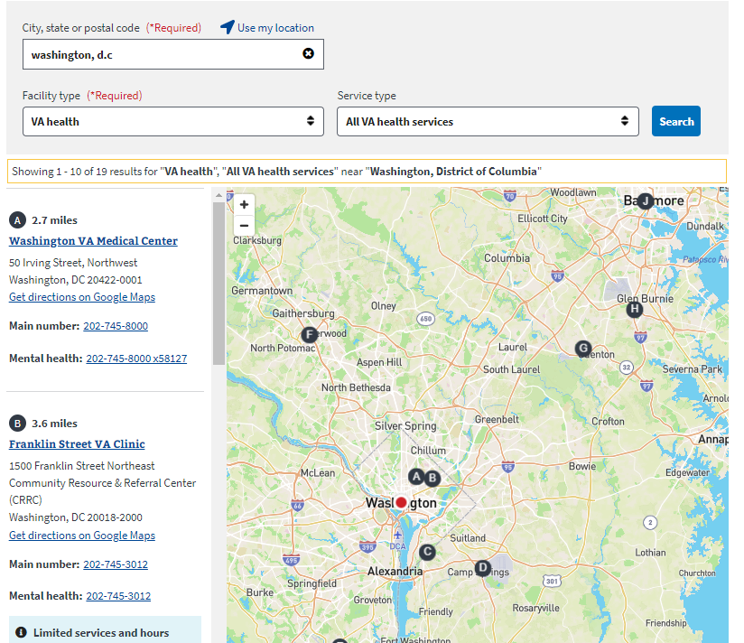

### VA facility search results

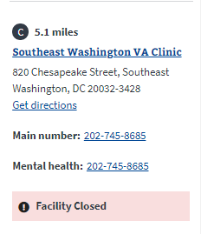

The facility cards contain the same basic information for most facility types:

* Corresponding pin
* Distance
* Name (with link to facility detail page)
* Address
* Actionable link to directions
* Main phone number
* Mental health phone number (VA health facilities)
* Facility operating status (if available)

VA health facilities include a VA health connect phone number in the search results card.

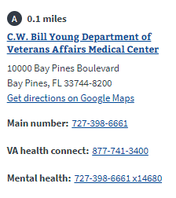

Search result cards for VA cemeteries include a “Learn more about burial status” link which connects to the Facility Detail page.

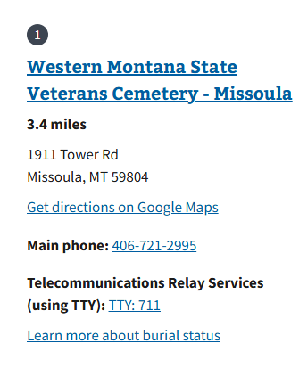

### Community provider search results

Community providers (in VA network) have referral language directing Veterans to call the facility if they have a referral and to contact their local VA medical center if they do not.

As previously mentioned, an alert is displayed in Community care result cards returned in urgent care searches.

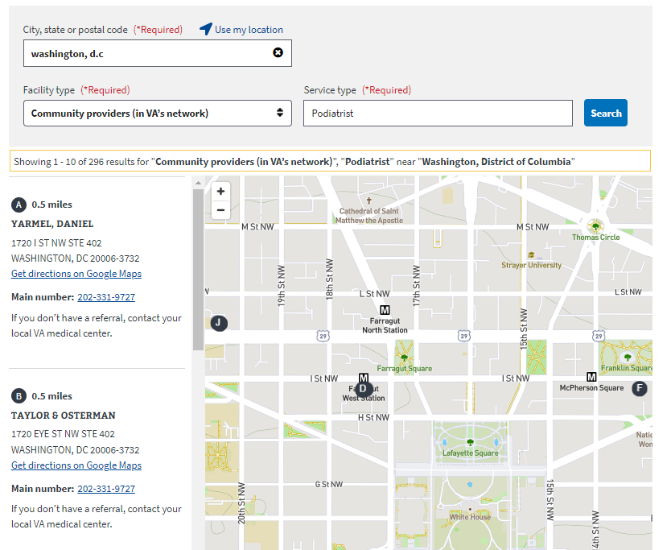

## 

## 

## Facility Detail Pages

### VA facility types

By clicking on the name of a VA location in search results, the Veteran can view details about the facility. The detail page displayed will depend on the type of VA facility.

Clicking on the name of a VA health facility connects to the modernized pages for that location. 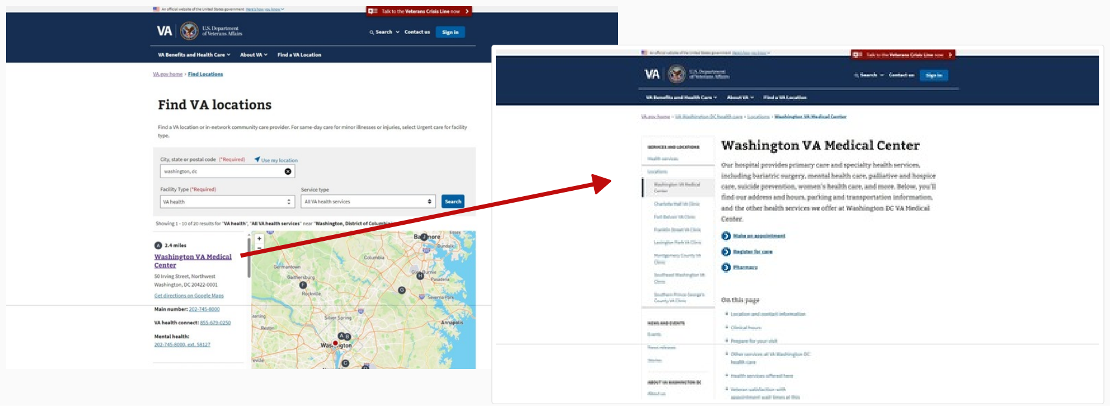

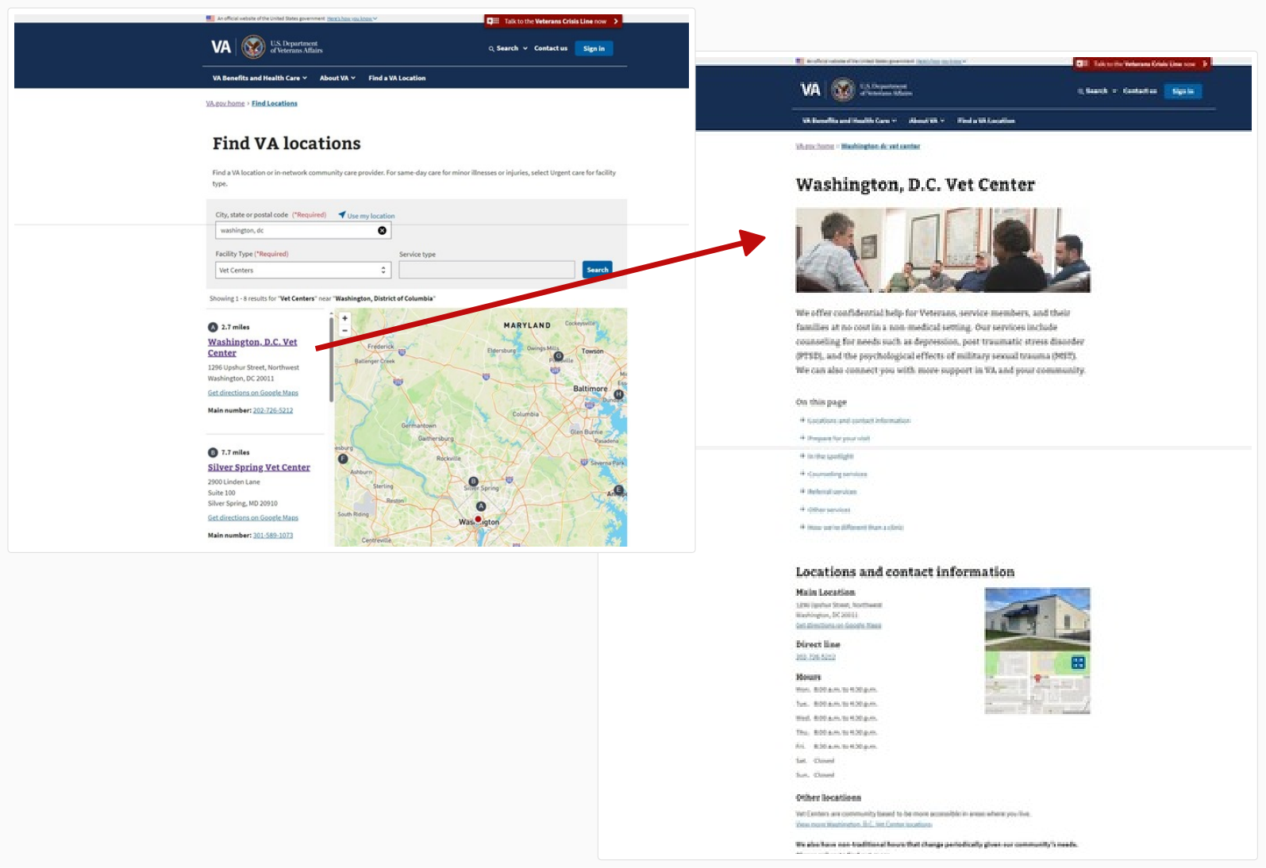

Clicking on the name of a Regional Benefit Office directs to new web pages if they are live on production at the time of the search. As of 9/19/2024, nine Regional Benefit Offices have web presence on VA.gov. If the location is not yet live, the legacy detail page is displayed.

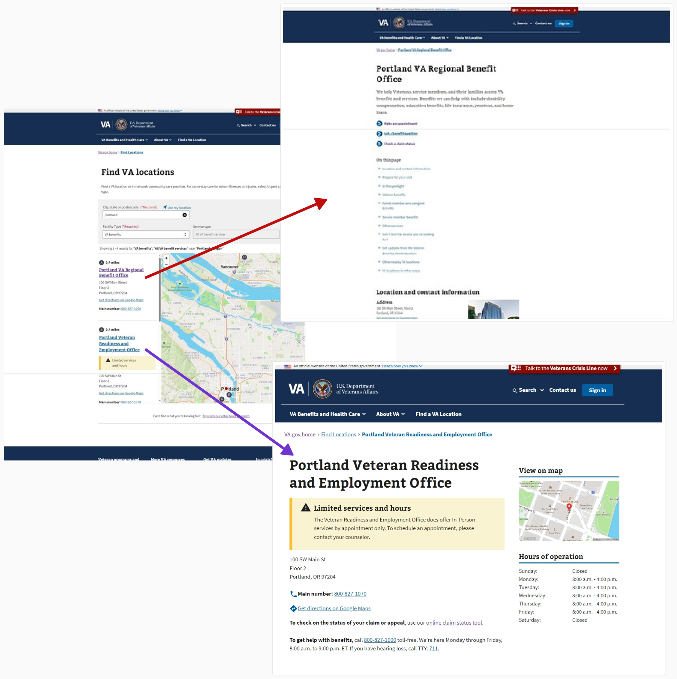

It’s important to note that the data on detail pages is presented as it is provided via the API. If information is not available, the entire block may be hidden.

Modernized pages use Drupal CMS as the source of truth.

Clicking on the name of a VA cemetery directs to a detail page which contains the location, contact information, and visitation hours for the cemetery and a link to the website (on <https://www.cem.va.gov/> for VA national cemeteries or the relevant page for a state or tribal location). The detail page also displays a burial status with definition to support Veterans and families during their time of need.

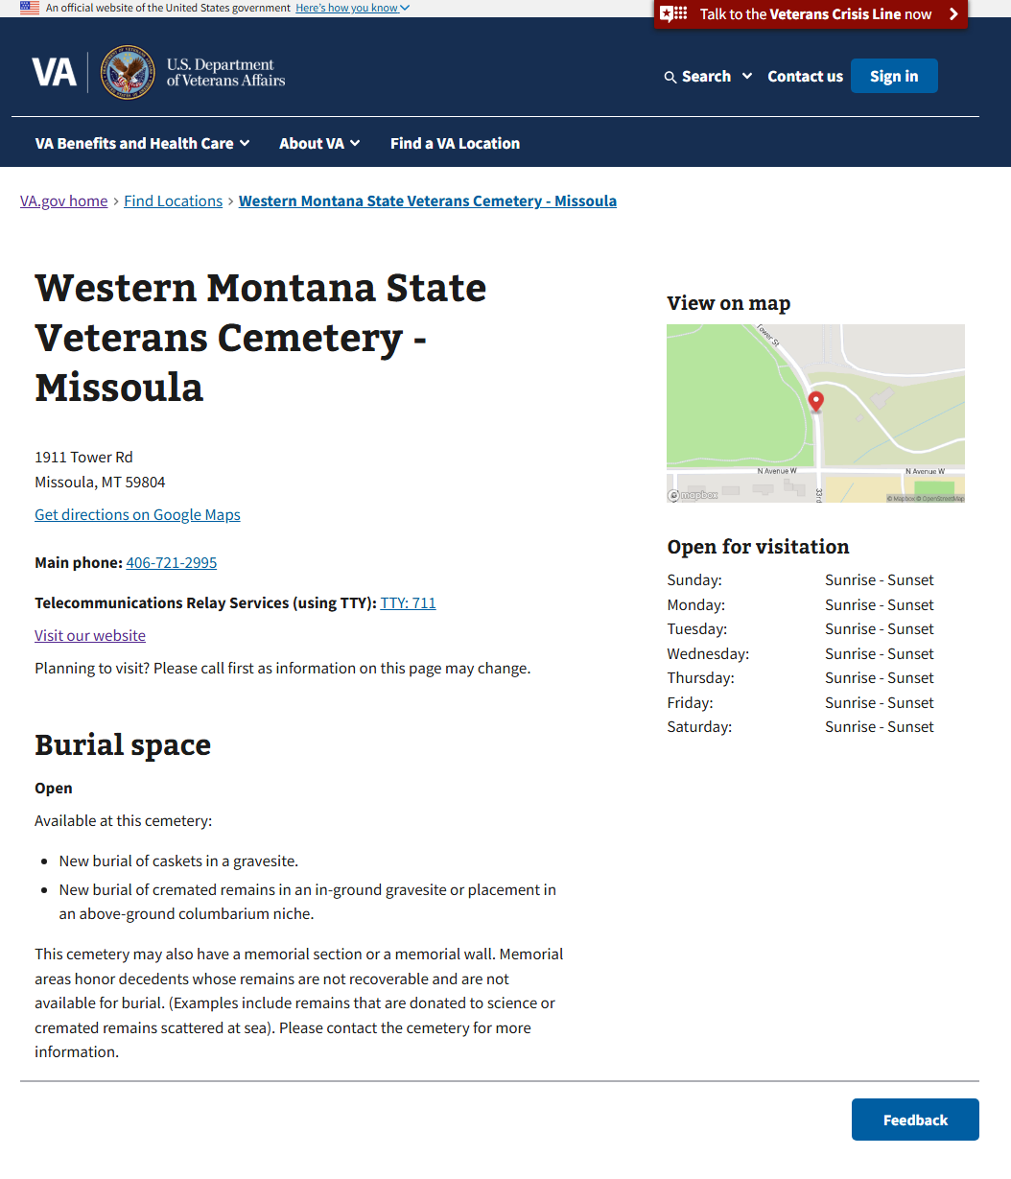

### Community providers (in VA network)

Facility detail pages are not available for Community providers (in VA network), Community urgent care, or Community pharmacies (in VA network).

## Facility-Level Operating Status

As of April 2020, search result cards may include an alert for facility-level operating status. This alert is to inform Veterans that a location may have temporarily changed access to the facility or services.

The status options which may be displayed are:

* Limited services and hours
* Temporary facility closure
* Virtual care only
* Temporary location
* Coming soon
* Facility Notice

No status is displayed if the facility’s operating status is set to Normal services and hours.

Veterans can learn more about the facility operating status by clicking on the facility name to view the detail page (as shown below for the National Capital Regional Benefit Office) or modernized facility page (as shown for the San Francisco Vet Center).

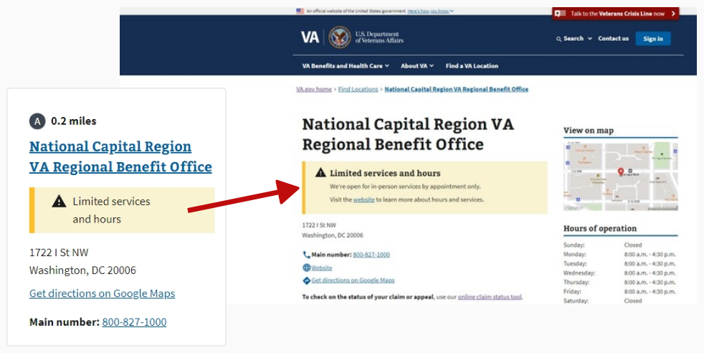 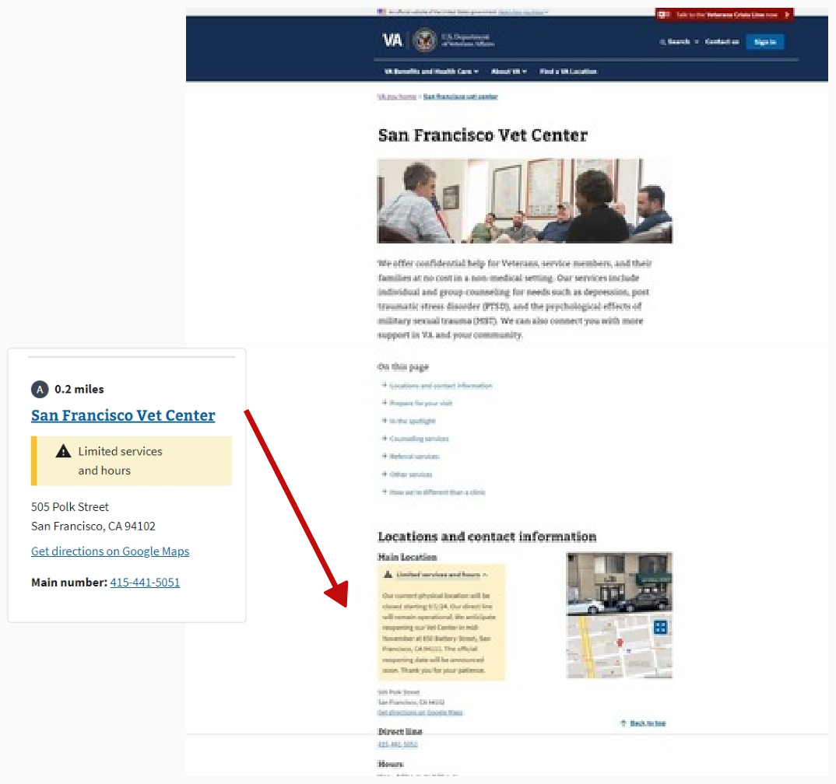

To view the details for a VA health facility, the Veteran must click on the name of the facility in search results and then click on the operating status displayed on the facility page. The details are shown on the operational status page.

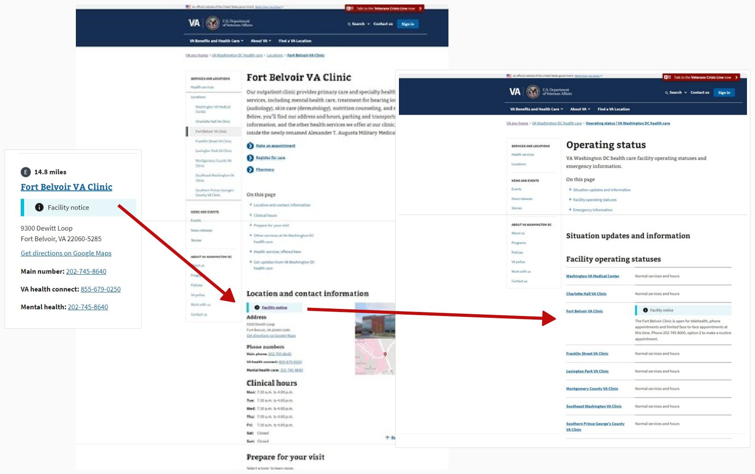

It is expected that the details may be different depending on the facility. Not all facilities will use operating status alerts.

## Error states and steps for resolution

Please see [separate documentation](https://github.com/department-of-veterans-affairs/va.gov-team/blob/master/products/facilities/facility-locator/error_states.md#error-states-and-steps-for-resolution).

## FAQ

**What if the Veteran believes the info displayed about the facility is incorrect? For example, they have received women’s care at the facility, but it isn’t listed as a service.**

The process for reporting inaccurate location information depends on the type of facility and information.

|  |  |  |
| --- | --- | --- |
| **Type of information needing correction** | **For facility type** | **Process** |
| Inaccurate **location information** such as address, phone number, hours or map thumbnails | VHA facilities  Vet Centers  VBA facilities  NCA locations | Contact Center agents should email the name of the facility and the missing or inaccurate detail to Lighthouse at api@va.gov. |
| Inaccurate **service information** | VHA facilities  Vet Centers  VBA facilities | Contact Center agents should email the name of the facility and the missing or inaccurate detail to Lighthouse at api@va.gov. |
| Inaccurate **location** or **service information** | * Community care providers and pharmacies (usually non-VA facilities) | Contact Center agents should email the name of the facility and the missing or inaccurate detail to [VHAOCCPPMSPROJBUSPOCS@VA.GOV](mailto:VHAOCCPPMSPROJBUSPOCS@VA.GOV). Please copy Michelle Middaugh, VA Product Owner at suzanne.middaugh@va.gov |

## Update Log

|  |  |  |
| --- | --- | --- |
| **Content** | **Section** | **Date** |
| Contact info for community care providers updated with Tobie Wethington’s information | FAQ | 5.7.2020 |
| Updated landing page image | User access | 12.17.2020 |
| Updated search box image and information about default field values | Navigation | 12.17.2020 |
| Updated image | Facility Detail page | 12.17.2020 |
| Updated image and description for Legacy Link | Legacy Directory Link | 12.17.2020 |
| Updated image | Search functionality > Location | 12.17.2020 |
| Updated description of the default for facility type field | Search functionality > VA facility | 12.17.2020 |
| Updated image for VA health default | Search functionality > VA facility > VA health | 12.17.2020 |
| Updated image and description of dropdown options | Search functionality > VA facility > Urgent care | 12.17.2020 |
| Updated image and description of Community urgent care alert button | Search functionality > VA facility > Urgent care > Alert for Community urgent care providers (in VA network) | 12.17.2020 |
| Inserted image and updated name to Community pharmacies (in VA network). Removed footnote. | Search functionality > VA facility > Community pharmacies (in VA network) | 12.17.2020 |
| Updated image | Search functionality > VA facility > VA benefits | 12.17.2020 |
| Updated image | Search functionality > VA facility > VA cemeteries | 12.17.2020 |
| Updated image | Search functionality > VA facility > Vet Centers | 12.17.2020 |
| Inserted section | Search functionality > Search this area of the map | 12.17.2020 |
| Updated image for map, search result list and individual card | Search results | 12.17.2020 |
| Updated image | Facility Detail pages > VA facility types | 12.17.2020 |
| Removed image and updated description | Facility Detail pages > Community providers | 12.17.2020 |
| Grammatical changes | throughout | 12.30.2020 |
| Addition of COVID-19 vaccines as a Service type under VA health facility searches | Search results | 01.27.2021 |
| Adjusted image sizing, plus any corresponding table of contents page numbers as needed; minor punctuation and capitalization edits. | throughout | 01.27.2021 |
| Updated image | Search functionality > Location | 03.04.22 |
| Updated image | Search functionality > VA facility > VA health | 03.04.22 |
| Updated image | Search functionality > VA facility > Urgent care | 03.04.22 |
| Updated image | Search functionality > VA facility > Urgent care > Alert for Community urgent care providers (in VA network) | 03.04.22 |
| Inserted image | Search functionality > VA facility > Community pharmacies (in VA network) | 03.04.22 |
| Updated image | Search functionality > VA facility > VA benefits | 03.04.22 |
| Updated image | Search functionality > VA facility > VA cemeteries | 03.04.22 |
| Updated image | Search functionality > VA facility > Vet Centers | 03.04.22 |
| Inserted information about VA health connect with image | Search results | 03.04.22 |
| Updated screenshots and details about facility information returned for COVID-19 vaccines searches | Search results | 03.04.22 |
| Updated images and descriptions | Facility Detail pages > VA facility types | 03.04.22 |
| Added link to error states and steps for resolution | Error states | 03.04.22 |
| Updated process for reporting inaccurate information and POCs | FAQ | 03.04.22 |
| Updated description and image for VA benefit search experience | Search functionality > VA facility > VA benefits | 09.19.2024 |
| Updated information about VA health connect numbers | Search results | 09.19.2024 |
| Removed information about COVID-19 vaccine specific details | Search results | 09.19.2024 |
| Updated information about modernized page availability for VA facility types | Facility Detail Pages > VA facility types | 09.19.2024 |
| Updated images for search experience for VA health facilities, Vet Centers, and Regional offices | Facility Detail Pages > VA facility types | 09.19.2024 |
| Updated images for operating status details | Facility operating status | 09.19.2024 |
| Updated process for reporting inaccurate information and POCs | FAQ | 09.19.2024 |
| Inserted information “Learn more about burial status” link in search result cards for VA cemeteries with image | Search results | 04.14.2025 |
| Removed exception for Manila Outpatient clinic as the modernized page is now live. | Facility Detail pages > VA facility types | 04.14.2025 |
| Added details for information displayed on VA cemetery detail pages and image | Facility Detail pages > VA facility types | 04.14.2025 |
| Updated possible Operating status options | Facility operating status | 04.14.2025 |